Tarnish on 18k Gold Watch Cases

Peter Toot

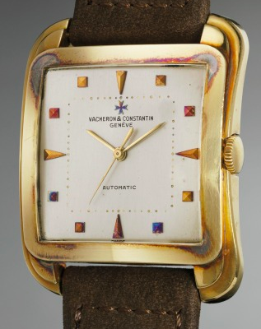

Image 1- Silver sulfide tarnish on a Vacheron Wristwatch
(https://www.phillips.com/detail/VACHERON-CONSTANTIN/CH080217/127?fromSearch=vacheron&searchPage=1)

Vintage gold watch cases occasionally show tarnish that appears as an red or blue iridescent or a black film. This tarnish typically develops on watches that have been stored for extended periods without handling and collectors commonly appreciate it as a sign that the case has not been polished recently. This tarnish is a type of corrosion, a degradation of a metal by an electrochemical reaction with its environment. It is a chemical reaction between one of the components of the watch case material and environmental sulfur gases that produces the tarnish. This paper will explain that chemical reaction and will also address simple steps that can be taken to help limit sulfide tarnish formation.
We have probably all heard that gold does not tarnish. Why then does tarnish form on gold watch cases? A basic understanding of the structure of gold will help answer this question. Pure gold is too soft to be used in watch cases and is typically combined with other metals for durability. Yellow gold in watch cases, for example, is commonly a combination of gold (Au), silver (Ag), and copper (Cu). This combination of metals creates an alloy, or amalgam of two or more metals.
Gold, like most metals, is crystalline in its atomic structure. In elemental form its atoms are held together by metallic bonding in which each atom is surrounded by many identical atoms in a latticework pattern. The outermost electrons of the atoms in the latticework are pulled in several different directions at once by neighboring atoms. This frees those electrons from their original atom and they move around the latticework randomly. This occurs in microscopic blocks called crystals, also referred to as grains. A piece of gold contains many of these crystals randomly combined in a polycrystalline aggregate.¹
The silver component in the gold alloys is completely miscible in the gold, meaning that the silver atoms randomly fill some of the atom positions within the gold latticework. The gold and silver combine in this way to form what is called a single-phase solution, meaning that all crystals have the same composition.² The copper component of the gold alloys is also miscible with gold. But, unlike silver with atoms that randomly replace gold in the crystalline latticework, the copper atoms replace gold in an ordered fashion within the latticework.³
This structure of the gold alloy helps to explain how the tarnish forms; it is the silver in the alloy that reacts with atmospheric sulfur to form silver sulfide, the tarnish we see on the watch cases. The tarnish forms as a thin layer of corrosion at the outermost layers of the metal object when it bonds with a non-metal. Tarnish, unlike rust, only affects the surface of the metal. A layer of silver sulfide tarnish inhibits the interaction of the watch case the with the environment as it thickens meaning that it is self-limiting.
At moderate relative humidity levels, water molecules adhere to the surface of the watch case. These microdroplets of water serve as a conductor in the electrochemical cell that causes the corrosion of the silver. Silver atoms from the gold alloy lose electrons in solution. These silver atoms become positively charged silver ions (Ag⁺¹). At the same time, sulfur ions disassociate from the hydrogen sulfide in the solution. A sulfur ion then bonds with two silver ions to form silver sulfide in the following chemical formula:

2Ag + H₂S ---> Ag₂S + H₂

The large quantity of the silver atoms undergoing this degradation discolors the gold alloys, covering the watch case's surface and partially or totally obscuring the presence of gold depending on the thickness of the tarnish.⁴ The initial film is not visible to the human eye until it is about 10 nanometers (nm) thick. From 10 nm to 100nm thick, the film appears as a yellow, red or blue color with an iridescent sheen due to some of the light being reflected at the surface of the tarnish and the rest of it being reflected by the gold (see Image 2 below). As the thickness of the tarnish reaches about 100nm, the iridescences fades as the tarnish begins to appear black in color.⁵

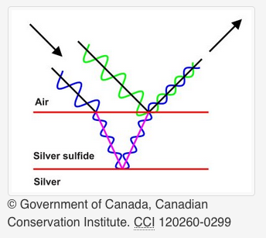

IMAGE 2- Corrosion Iridescence

Silver sulfide tarnish on watch cases appears primarily on those made of yellow gold alloys. The percentage of gold in the alloy is typically expressed as karats which are 24th of the total weight, with 24-karat gold being pure. The 18-karat yellow gold typically used in watch cases is an alloy containing 75% gold with 12.5% copper and 12.5% silver. Exact percentages often vary but red gold, also called 5N rose gold, is traditionally 75% gold, 20.5% copper and 4.5% silver while 4N rose gold is 75% gold, 16% copper and 9% silver. White gold commonly has 75% gold, 10% palladium, 10% nickel and 5% zinc but occasionally does contain a small percentage of silver. The image below helps illustrate the makeup of different golds commonly used in watch cases.

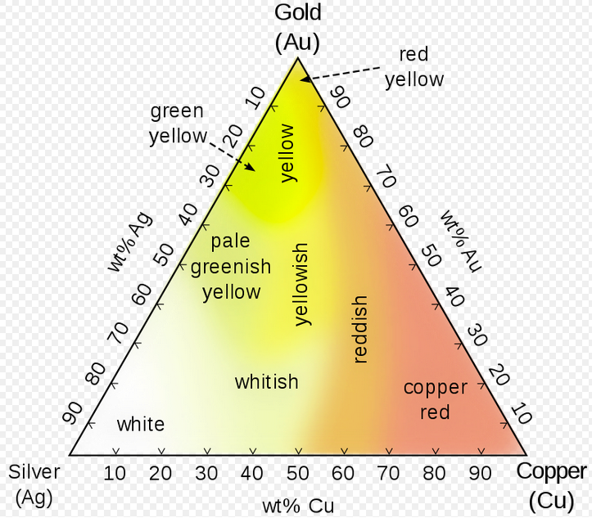
IMAGE 3- Composition of gold alloys
(en.wikipedia.org/wiki/Gold, no date)

Rose gold watch cases seem to be less susceptible to silver sulfide tarnish due to the lower percentage of silver in their composition. This lower percentage of silver means that the case has less substrate for the silver sulfidation process. White gold often does not include silver making silver sulfidation in on those cases impossible. White gold is also typically plated with rhodium to increase its brightness so even when the alloy does contain silver, the rhodium plating helps prevent the interaction of the silver with the environment that would lead to tarnish formation.

Preventative Treatment

While the collector community seems to have a positive association with silver sulfide tarnish on watches, it can mar the appearance of a watch. Normal wear and handling seem to be sufficient to keep the silver sulfide tarnish layer below the visible threshold level of 10 nanometers on watches. This is presumably due to what amounts to the very light polishing action generated by normal wear and handling. As a result, it is the cases that have been stored or not handled for extended periods that seem to show the most sulfide development. Tarnish also commonly appears on hour markers, such as on the Vacheron Constantin watch pictured above. Controlling storage conditions for these watches can help limit the tarnish formation. Three simple, passive measures can be employed easily to limit tarnish formation: air circulation, the control of relative humidity and the use of scavengers.
There are several environmental sulfurs that can contribute sulfide ions to tarnish formation including carbonyl sulfide, sulfur dioxide and hydrogen sulfide. This paper focuses on hydrogen sulfide's role in tarnish formation because environmental hydrogen sulfide is primarily responsible for sulfidation. Hydrogen sulfide has several sources. Bacterial breakdown of plant and animal material, volcanoes and hot springs all produce the gas. Industrial sources of hydrogen sulfide include petroleum and gas extraction and refining as well as paper and textile production.⁶ Hydrogen sulfide levels can vary geographically as a result of proximity to these sources.
Silver sulfidation from hydrogen sulfide can occur at levels as low as several parts per trillion and this is one of the major difficulties for collections management presented by hydrogen sulfide. This concentration is below typical indoor levels of hydrogen sulfide of 50-100 ppt.⁷ Monitoring hydrogen sulfide levels is, in itself, difficult as no commercially available sampling device is sensitive enough to detect hydrogen sulfide at threshold levels for silver sulfidation.⁸
Good ventilation and high air circulation in storage areas are therefore practical ways to limit hydrogen sulfide levels and resultant tarnish formation on watches that are stored for extended periods. A Getty Foundation study found that the highest levels of pollutants in museums were typically in display cases or storage cabinets where air circulation is restricted allowing for pollutants such as hydrogen sulfide to accumulate.⁹
Because silver sulfide tarnish forms in chemical cells in microdroplets of water, another important factor in controlling sulfidation is limiting the relative humidity levels where watch cases are stored. Relative humidity can easily be monitored with a hygrometer and can be limited with the use of dehumidifiers or dry silica bags. Ideal storage conditions would have the relative humidity level as low as possible to prevent water from adhering to the object's surface and creating a corrosion cell.¹⁰ These ultra-low relative humidity condition would be difficult to maintain. They also would be ill-advised for watch storage due to negative effects on associated leather straps and the fact that carriers in some synthetic lubricants can evaporate. A compromise relative humidity level would have to be determined taking account of these two factors.
So-called scavengers offer the third possibility to reduce silver sulfide formation. By placing silver pieces in storage areas with watches, some of the hydrogen sulfide which is in the storage case will interact with the silver pieces and form tarnish on them, not on the silver components of the watch cases. These silver pieces will develop sulfide tarnish on them and it should periodically be polished off to maintain the effectiveness of the scavengers.
Lacquering is not a common technique in watch collecting but it represents an interesting possible solution for investment-grade watches that will be stored for long periods. Lacquering is the application to silver objects of a film barrier to prevent silver sulfidation in museums. The term lacquering originally referred to the application of shellac but the technique now employs a variety of film-forming materials. The film applied to the case ideally would prevent the contact between sulfurs and the silver ions thus preventing the chemical reaction that forms silver sulfides. This is an involved process to be performed by experienced conservators.
Finally, if it is determined that the tarnish should be treated, polishing removes the tarnish through a physical force breaking chemical bonds. While highly effective in terms of the removal of the tarnish, this process also removes some of the underlying metal, reducing slightly the shape of the case and softening the crispness of its details. The vintage watch market currently holds strong views against polishing because of the loss of material and best practice would be to limit the formation of silver sulfide tarnish instead of removing it by polishing.

Conclusion

The presence of silver sulfide tarnish on yellow gold watch cases is currently not viewed as problematic by collectors and, in fact, this tarnish is often interpreted as a sign that the case has not been polished. Better understanding of silver sulfide tarnish and its formation could lead to a desire to prevent its formation with the aim of preserving the visual integrity of watches. Preventive environmental controls such as limiting the exposure of watches to environmental sulfurs, controlling relative humidity and the use of scavengers will help in limiting the formation of silver sulfides on watches.

References

1. Dorning, p.3
2. Selwyn, p.7
3. Ibid, p.76
4. Ibid, p.79
5. Ibid, p. 138
6. New York State Department of Health, 2005.
7. Selwyn, p.137
8. Grzywacz, p.29
9. Grzywacz, p.4.
10. Canadian Conservation Institute, 2007.

Reference List

Dorning, D. (2018) 'Metals and Their Microstructure', West Dean College. Unpublished

Grzywacz, C. 'Monitoring for Gaseous Pollutants in Museum Environments', Tools for Conservation. Los Angeles, CA: Getty Publications, 2006:

Selwyn, L. Metals and Corrosion, A Handbook for the Conservation Professional. Ottawa: Canadian Conservation Institute, 2004: 7,76,79,131,137.

Internet Sources

Canadian Conservation Institute 'Storage of Metals' (2017) Accessed: January 15, 2018 https://www.canada.ca/en/conservation-institute/services/conservation-preservation-publications/canadian-conservation-institute-notes/storage-metals.html

New York State Health Department 'Hydrogen Sulfide Chemical Information Sheet' (2005) Department of Health Accessed: January 20, 2018 https://www.health.ny.gov/environmental/chemicals/hydrogen_sulfide/

Wharton, G. 'The Cleaning and Lacquering of Museum Silver'. WAAC Newsletter, vol. 11, no. 1. Jan. 1989. Accessed: January 20, 2019 http://www.cool.conservation-us.org/waac/wn/wn11/wn11-1/wn11-103.html

en.wikipedia.org/wiki/Gold (Accessed, January 22, 2018)

www.phillips.com/detail/VACHERON-CONSTANTIN/CH080217/127?fromSearch=vacheron&searchPage=1

FIGURE CAPTIONS

IMAGE 1- Silver sulfide tarnish on a Vacheron Wristwatch

IMAGE 2- Corrosion Iridescence

IMAGE 2- Composition of gold alloys

ABOUT THE AUTHOR

Peter Toot is a WOSTEP-trained watchmaker and graduate of West Dean College's Horological Conservation program. He lives in New Mexico and specializes in marine and pocket chronometer repair and service. Learn more about what he does at www.cdshorology.com

Key words: gold tarnish, watch storage, limiting tarnish

